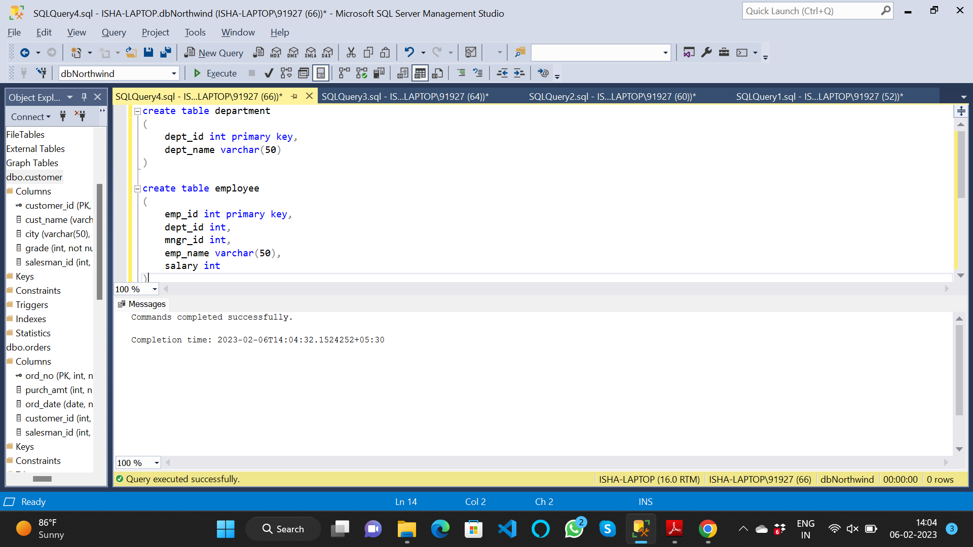

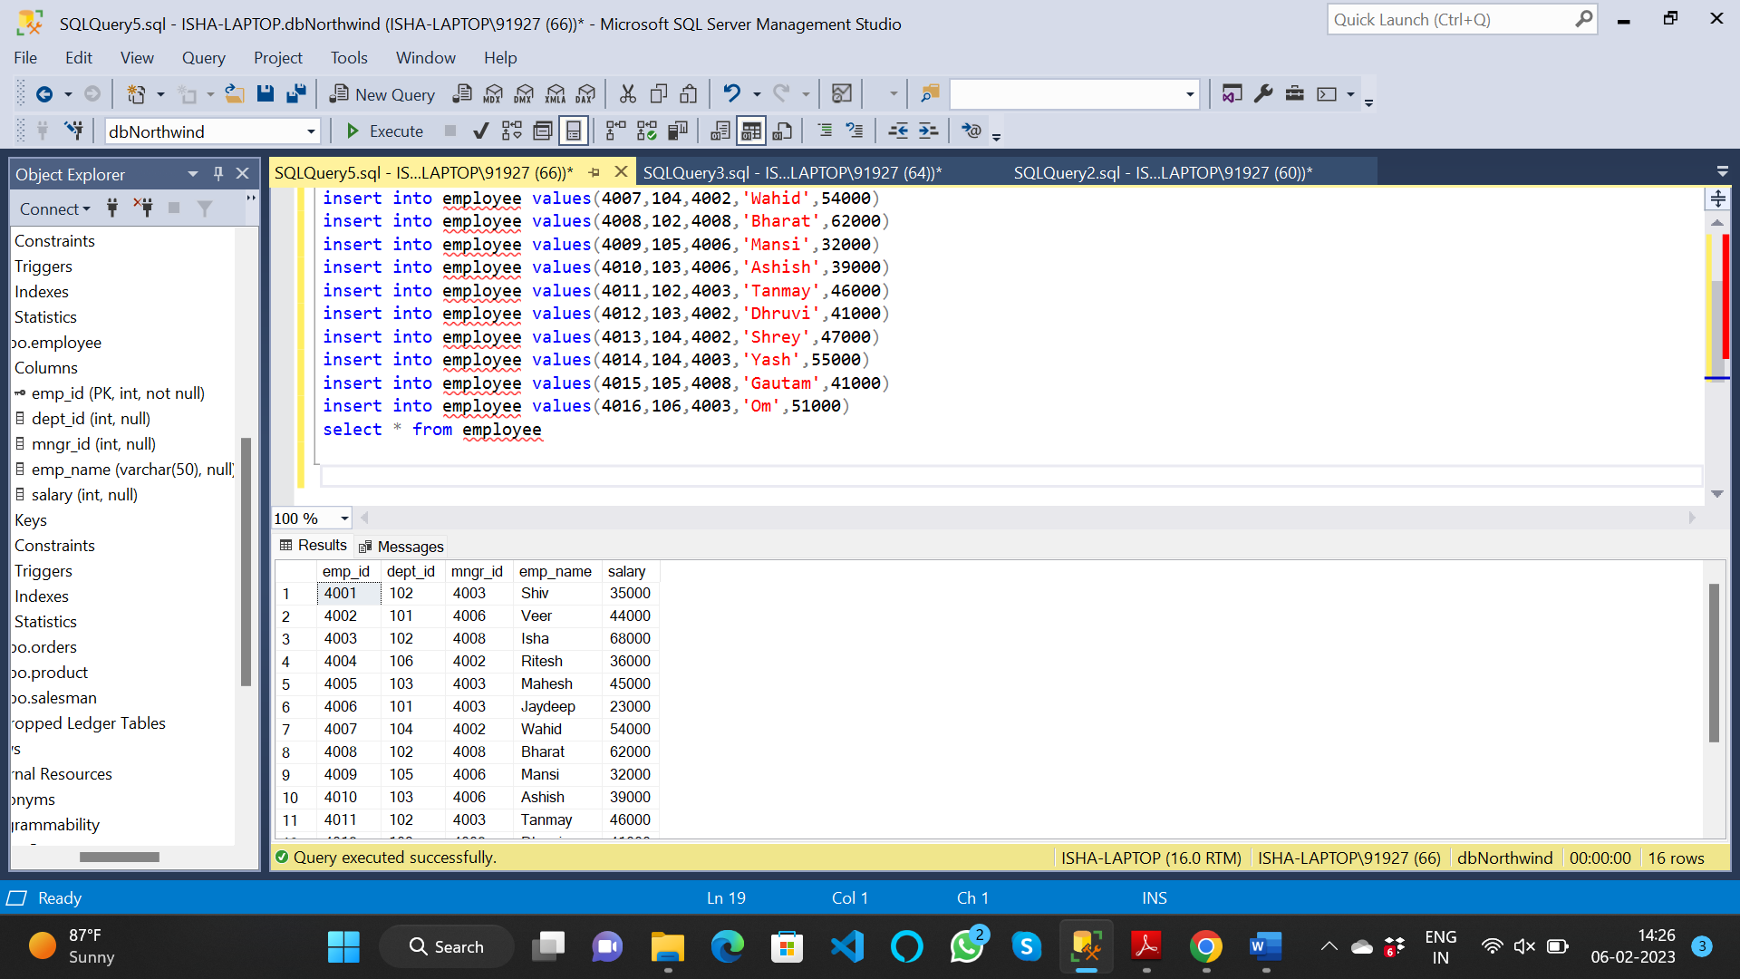

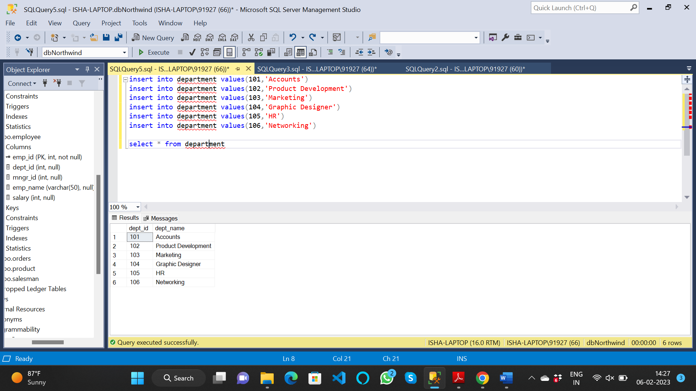

1. write a SQL query to find Employees who have the biggest salary in their Department

create view max_sal_emp as

select employee.dept_id, max(employee.salary) as max_sal

from employee join department

on department.dept_id=employee.dept_id

group by employee.dept_id

select employee.dept_id,employee.emp_name, max_sal_emp.max_sal

from employee join max_sal_emp

on employee.dept_id=max_sal_emp.dept_id and employee.salary=max_sal_emp.max_sal

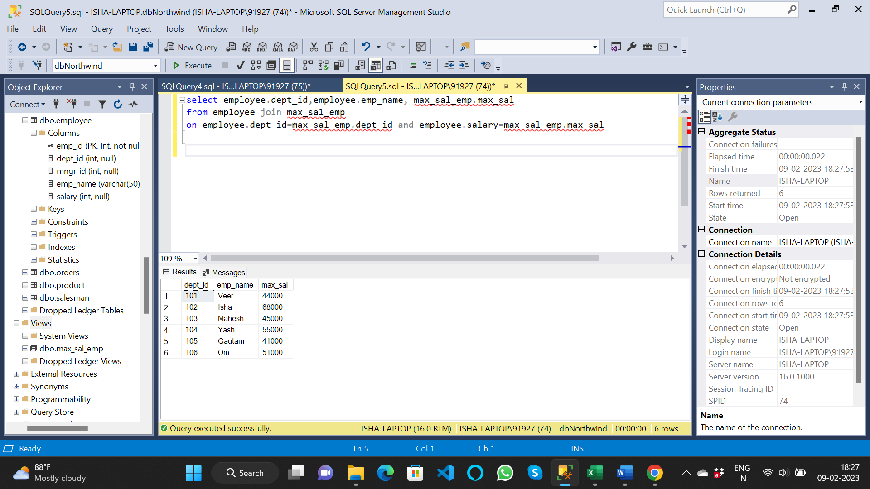

2. write a SQL query to find Departments that have less than 3 people in it

select dept_id,dept_name

from department

where dept_id in (select e.dept_id from employee e group by dept_id having count(*)<3)

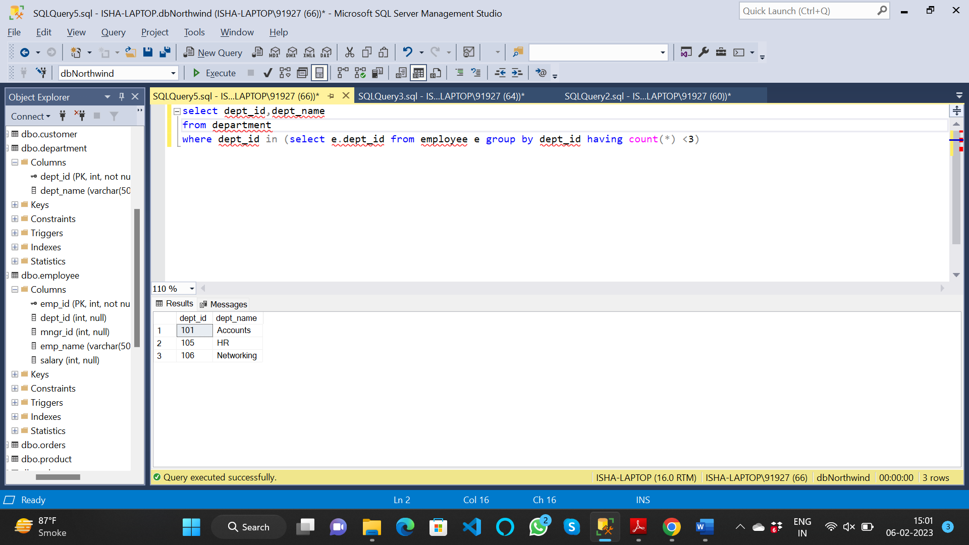

3. write a SQL query to find All Department along with the number of people there

select d.dept_name, count(*) as [no. of employee]

from employee e join department d

on d.dept_id=e.dept_id

group by d.dept_name

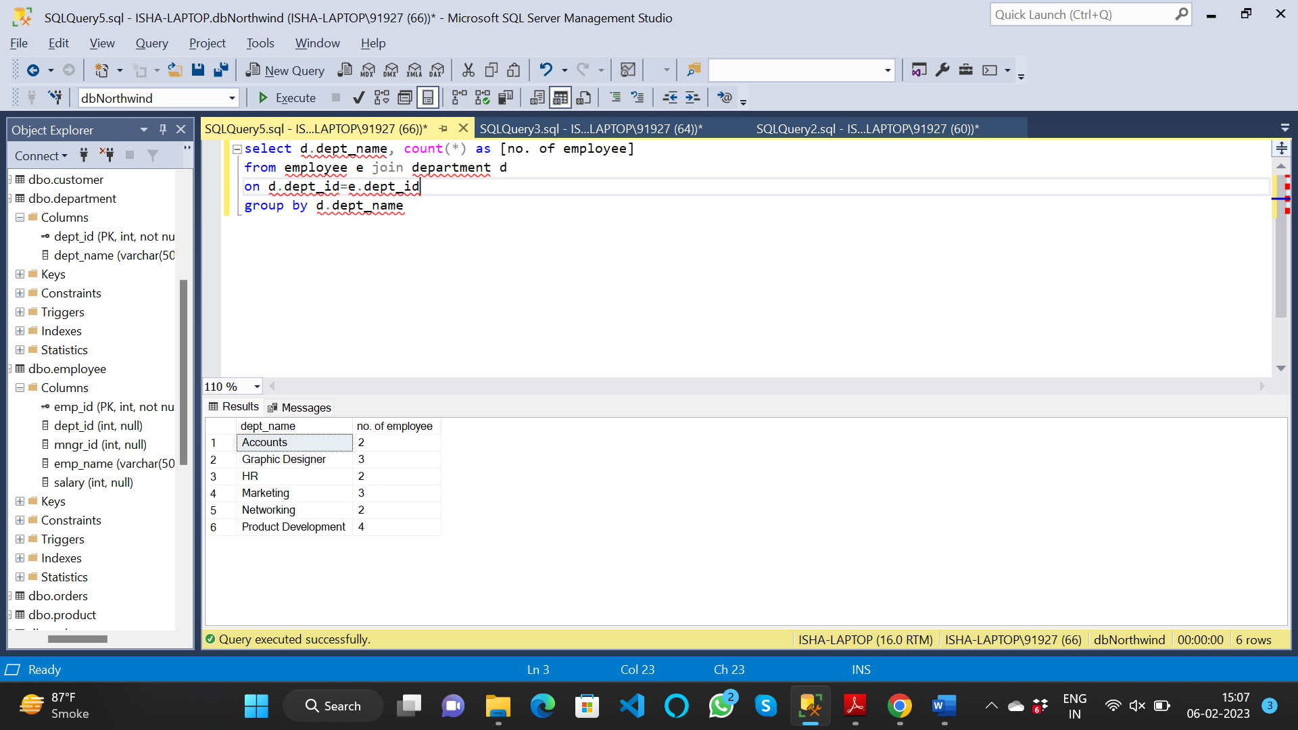

4. write a SQL query to find All Department along with the total salary there

select d.dept_name, sum(e.salary) as [no. of employee]

from employee e join department d

on d.dept_id=e.dept_id

group by d.dept_name

